## **Key question**: How have voting patterns of Black populations in Boston changed by election type?

PROCESS: After collecting missing data, we performed some preliminary analysis focusing mainly on how voting patterns change with Black demographics.

**Part 1: Senate 2020 Demorcratic Primaries and 2018 US Democratic House Primaries**

1. For the Senate 2020 Democratic Primaries, here is what we found:

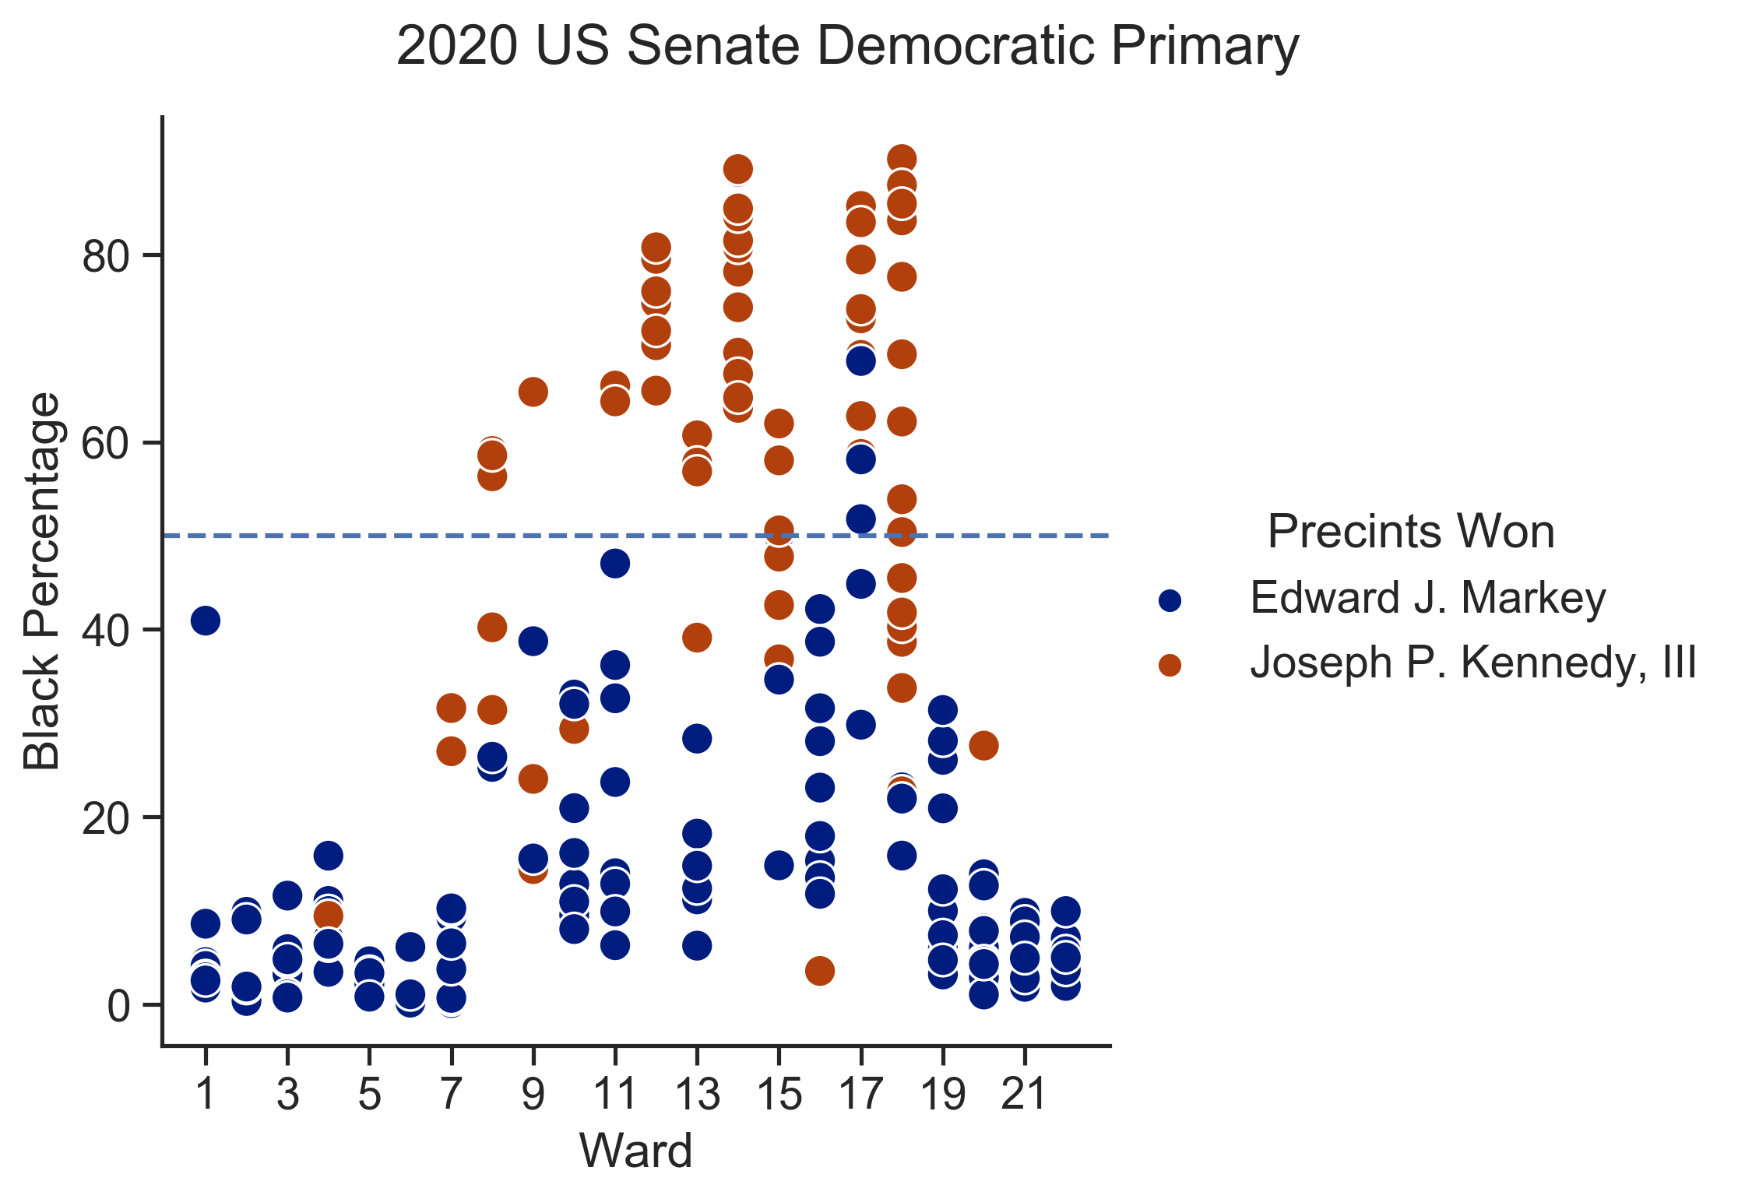

Here we found a clear racial pattern. Across all Wards, Kennedy won most of the precincts with Black majority as we can notice above the horizontal line, while Markey dominated the precincts with Black minority, and specifically the ones with lowest Black percentage living there.

1. And for the 2018 US Democratic House Primaries:

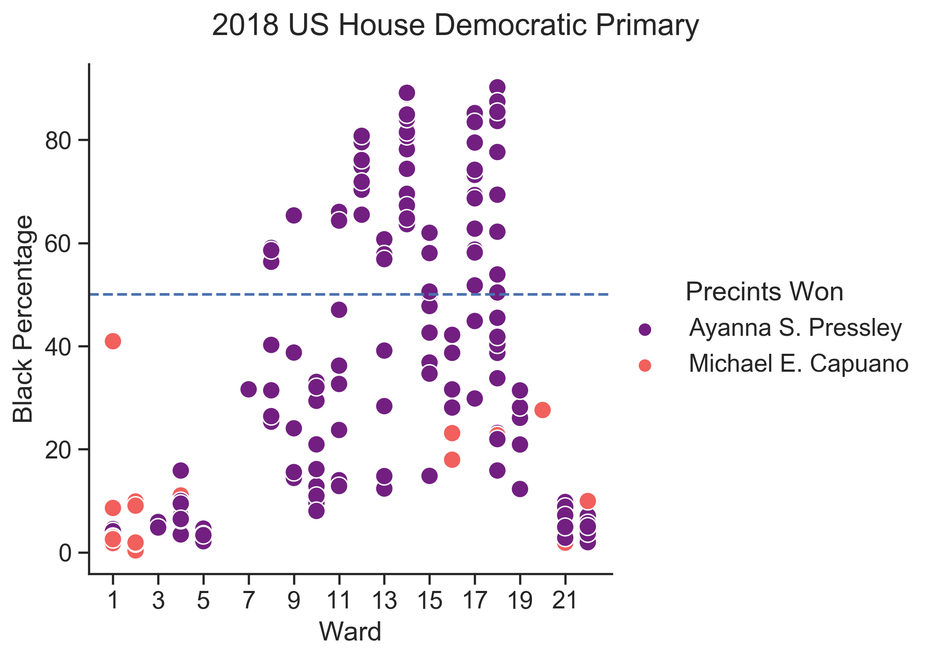

Similarly, another racial pattern. Across all Wards, Pressley won all of the precincts with Black majority as we can notice above the horizontal line, while Capuano’ wins were in the precincts with Black minority, with most of them being in lowest Black percentage precincts.

**Part 2: Mayoral 2017 Preliminary Race and Mayoral 2017 General Turnout Race**

1. For the Mayoral 2017 Preliminary Race, we obtained the following results:

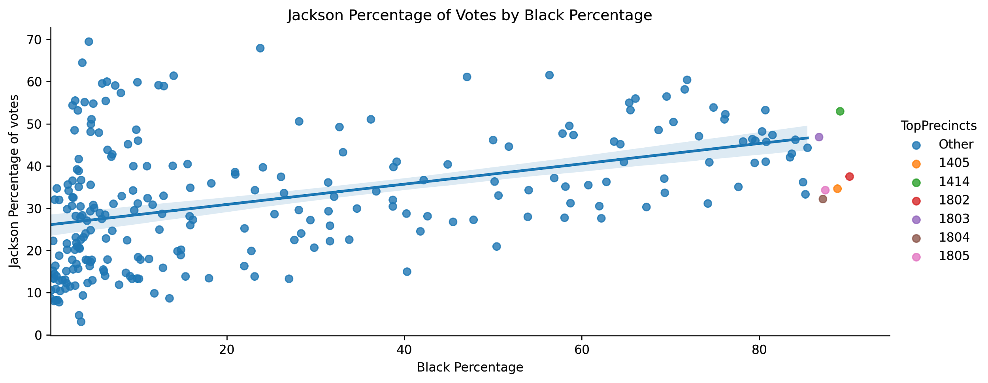

Here, we found that there is a slight positive correlation (correlation coefficient: 0.42) between a higher Black population and greater percentage of votes for Tito Jackson.

Similarly, we analyzed Marty Walsh’s percentage of votes by Black Percentage:

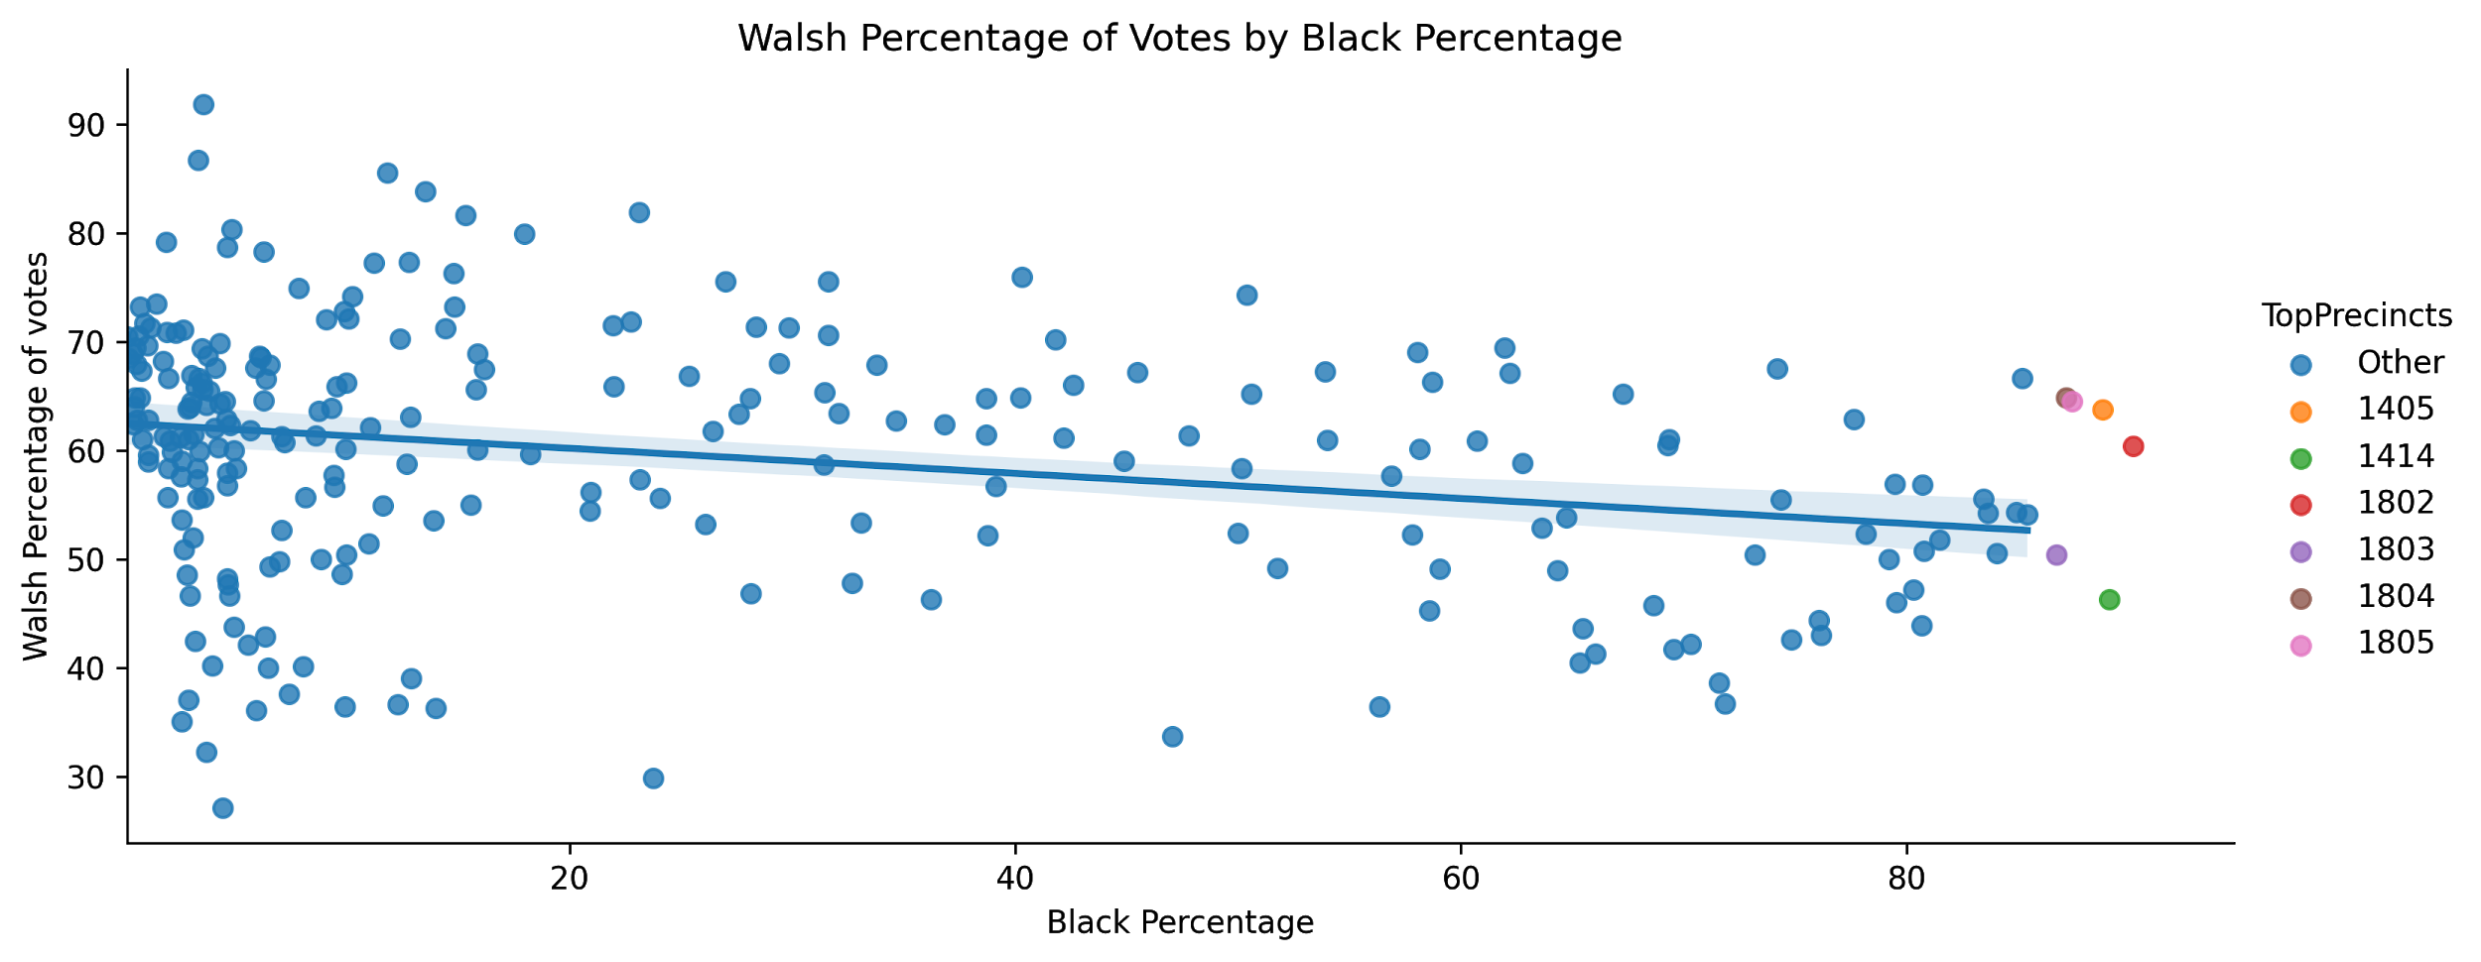

Finding that there is a slight negative correlation (coefficient: -0.25) between the two.

1. For the Mayoral 2017 General Turnout Race, we obtained the following results:

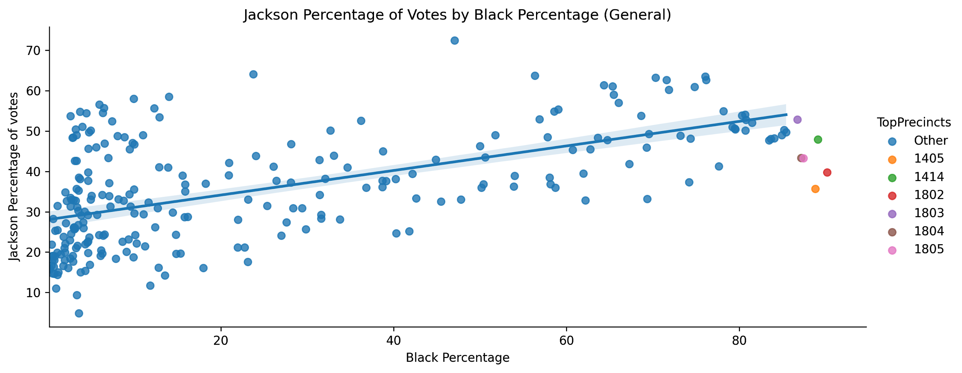

In the general race, there was a slightly stronger positive correlation between Jackson’s percentage of votes and the Black population per precinct, with correlation coefficient of 0.58.

Similarly, analyzing Marty Walsh’s percentage of votes by Black Percentage:

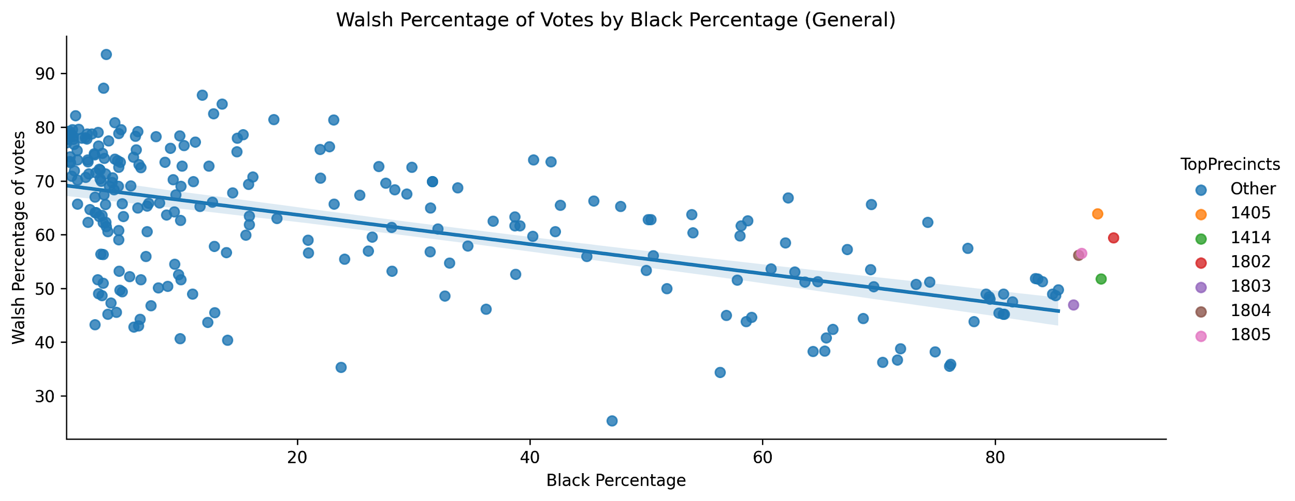

Here, we found a much stronger negative correlation of -0.56.

**Part 3: Presidential Elections 2020 and 2016 Presidential Elections**

1. For the Presidential Elections, we obtained the following results:

First, we analyzed the 2020 Trump/Biden race by Black Percentage per Boston precinct:

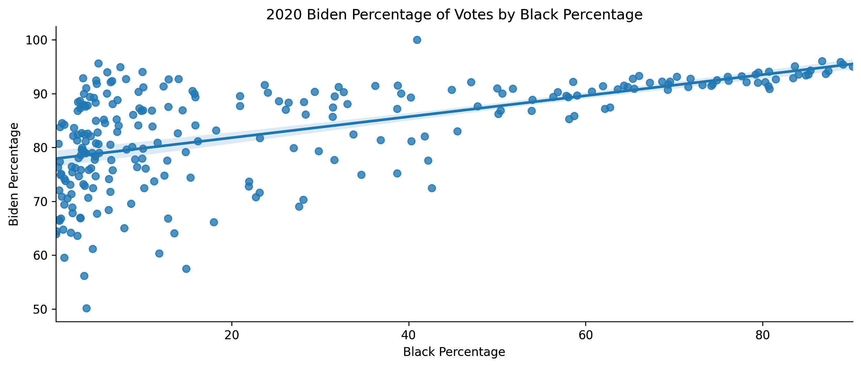

Here, we have a correlation coefficient of 0.58, indicating a positive correlation.

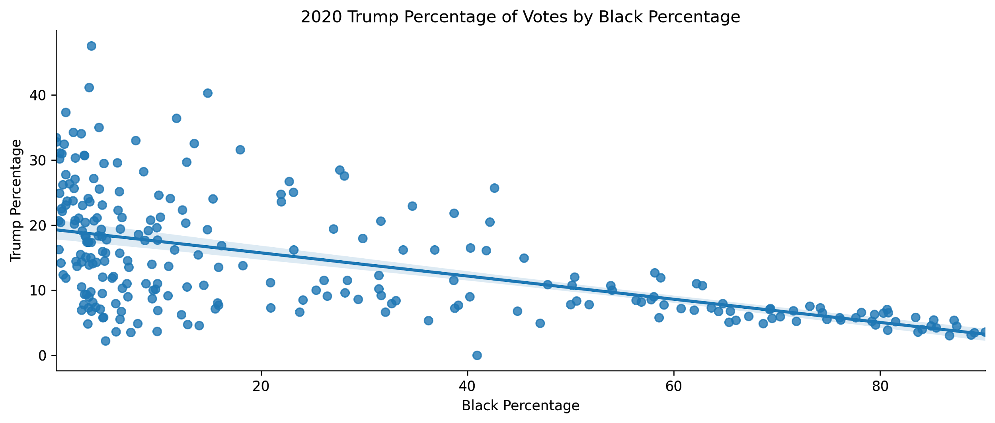

Here, we have a correlation coefficient of -0.55, indicating a negative correlation between Black Percentage per precinct and Trump’s percentage of votes.

Sorting our precincts by By Black Population Percentage:

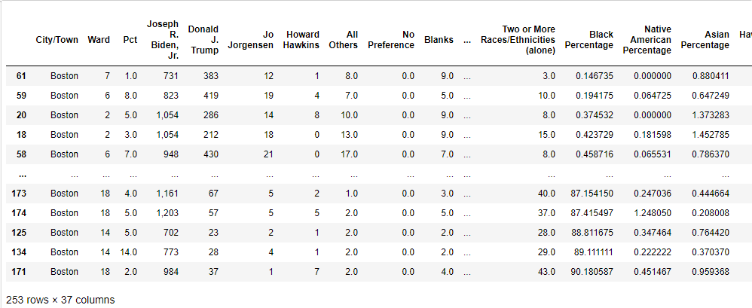

1. Next, we analyzed the 2016 Trump/Clinton race by Black Percentage per Boston precinct:

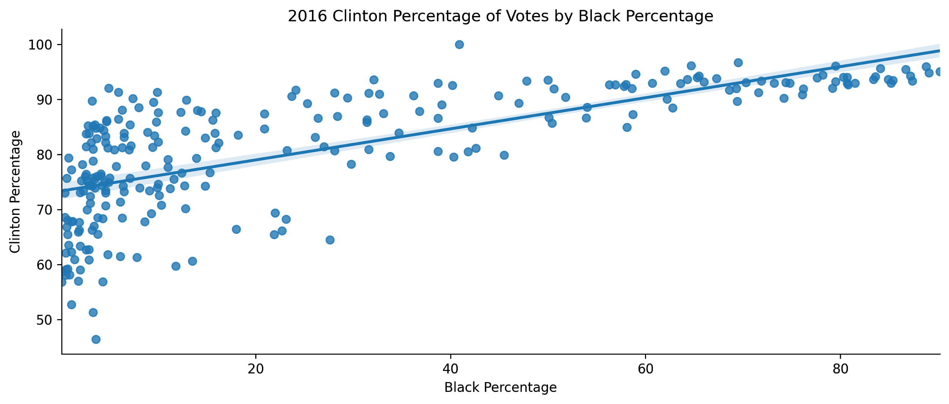

Here, we have a correlation coefficient of 0.71, indicating a strong positive correlation.

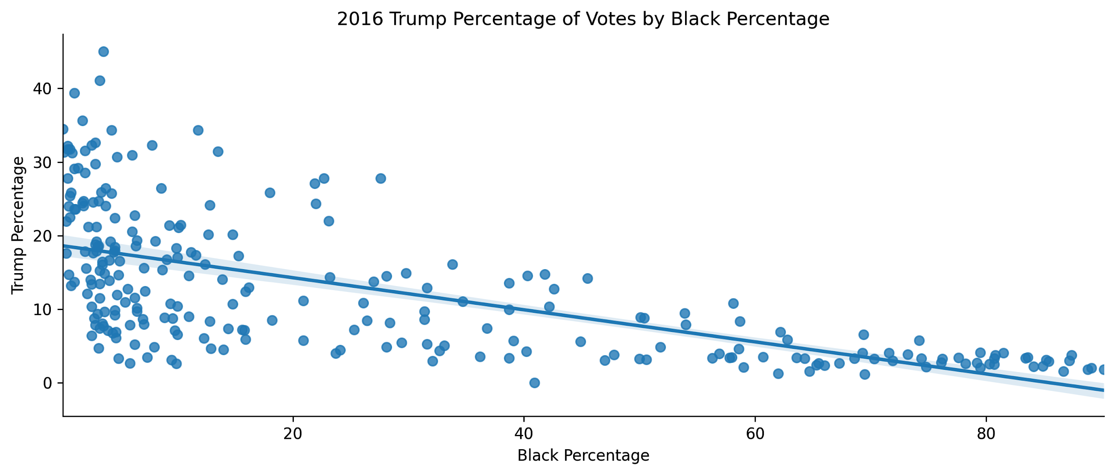

Here we have a correlation coefficient of -0.63, indicating a strong negative correlation.

**Part 4: DA Race Turnout 2018**

1. For the DA Race Turnout 2018, we obtained the following results:

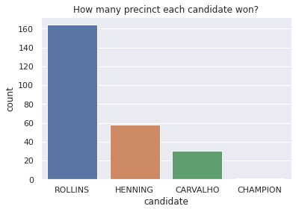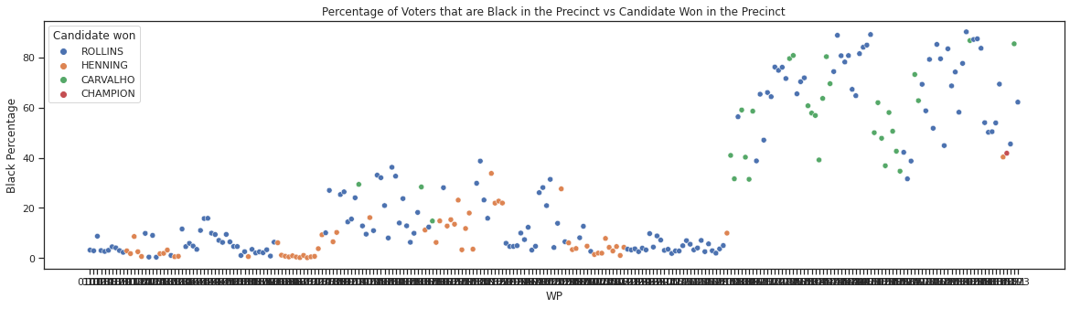

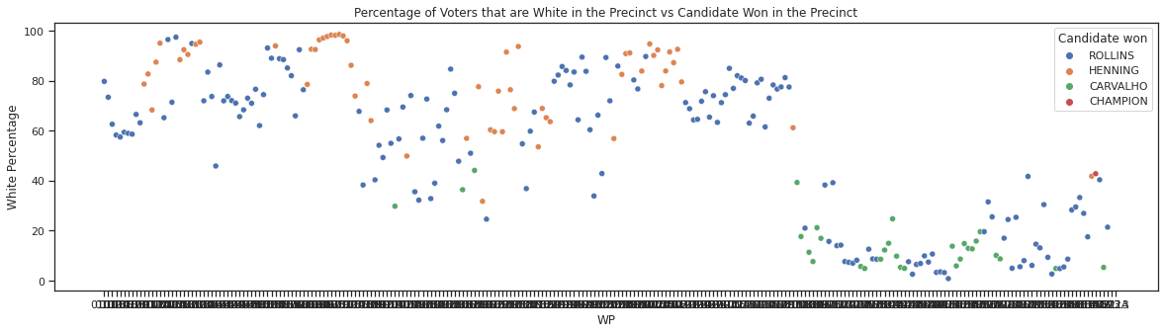

For precincts with a high percentage of voters that are black, the candidate, Rolling, seems to be favored more than other candidates. Henning, who also won a lot of precincts, doesn’t seem to be favored by black people as most of his winning precincts are from precincts with a dense white population.

**Part 5: City Council Result Analysis including 2011, 2013, 2015, 2017 and 2019**

1. 2011 City Council Result

* Individual vote counts vs black percentage

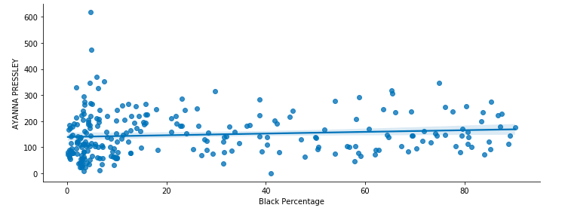

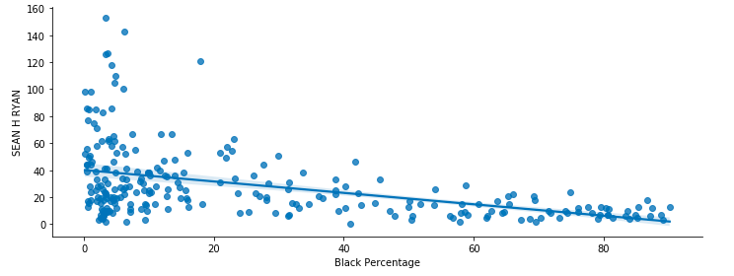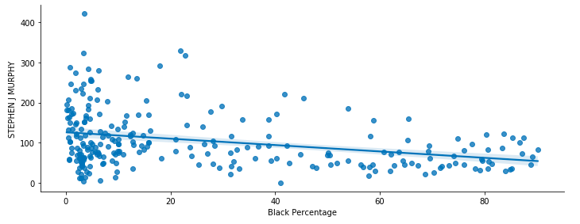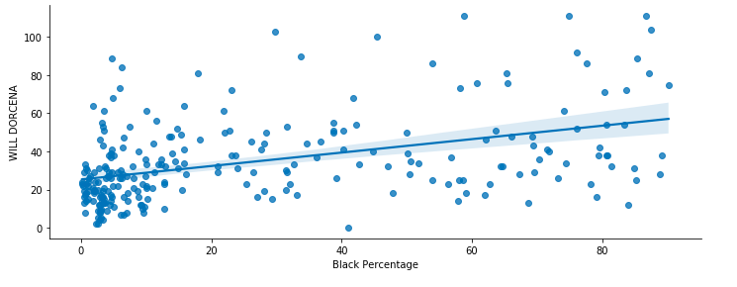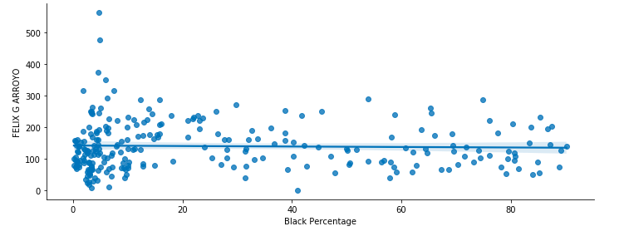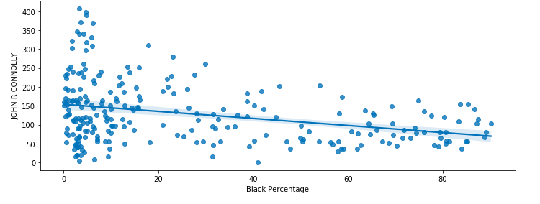

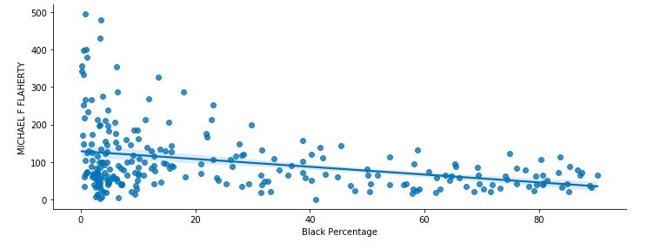

From the plot, we can see that Will Dorcena has the strongest positive correlation between black percentage and vote counts. Ayanna Pressley has a slight positive correlation. John R Connoly, Michael F Flaherty and Sean H Ryan all have negative correlation. According to Wikipedia, Ayanna Pressley is a black woman and Will Dorcena is a black man. The rest of the candidates are white men. Thus, the finding is not surprising and it confirms the hypothesis that black voters are more likely to vote black candidates.

* Winner in each precinct vs black percentage

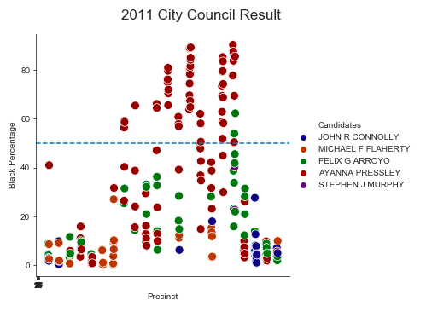

From the graph we can see that Ayanna Pressley is leading in precincts that have large black percentages. Felix, who has similar vote counts with Ayanna, his supporters are mostly in neighborhoods that have large white populations.

1. 2013 City Council Result General Analysis

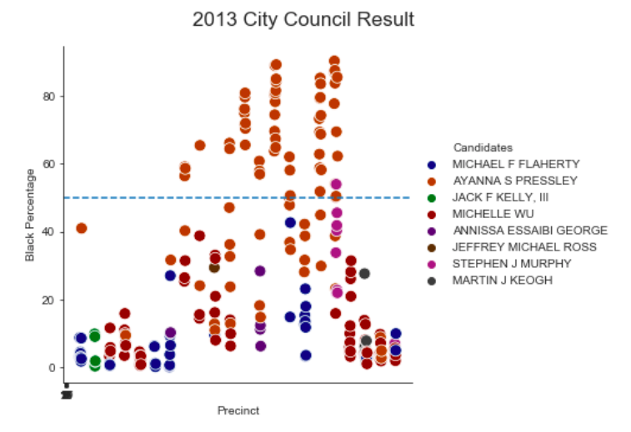

We can see that Ayanna Pressley, the only black candidate, is still leading in precincts that have large black percentages.

1. 2015 City Council Result General Analysis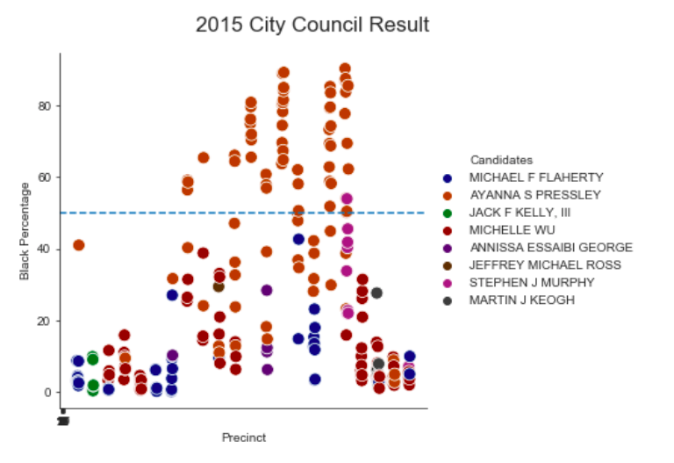

We can see that Ayanna Pressley, the only black candidate, is still leading in precincts that have large black percentages.

1. 2017 City Council Result General Analysis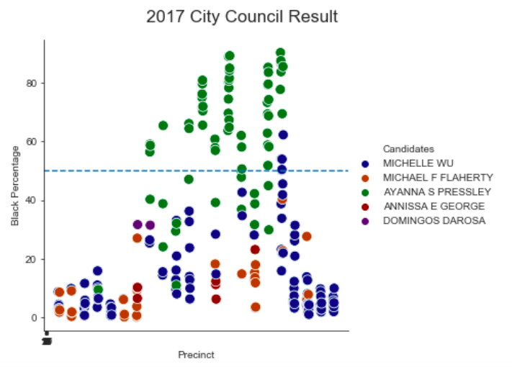

We can see that Ayanna Pressley, the only black candidate, is still leading in precincts that have large black percentages.

1. 2019 City Council Result General Analysis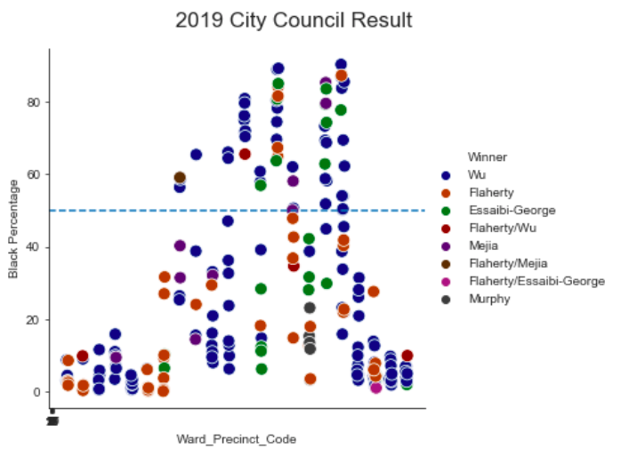

In 2019, there is no black candidate, so the winner in precincts that have a large black population is pretty random.